**2025 Raffle Rules**

**Prize: 2026 Toyota Corolla SE  
Ticket: $10 Donation**

The raffle drawing will take place on November 8, 2025, during the YATC Classic®. Winner need not be present.

Rules governing the drawing: 1. The Youth Automotive Training Center of Broward, Inc. ® [a non-profit charitable organization - 501(c)(3)] (“YATC”), whose principal place of business is 399 SW Martin Luther King Jr. Avenue, Deerfield Beach, FL, 33441, will sponsor a drawing for a **2026 Toyota Corolla SE**. The drawing will be held at the PGA National Resort in Palm Beach Gardens, FL, on November 8, 2025 during the YATC Classic at 7:00 pm. The winner will be selected through a random, blind drawing from the tickets distributed from October 1, 2025 through November 8, 2025 by YATC representatives. No contributions are required. 2. Persons must be eighteen (18) years of age or older to enter and win. Employees of PricewaterhouseCoopers LLP and their immediate family members living in the same household, officers, directors and associates of YATC and all Executive Management Team members, Board of Directors and Board of Trustees of JM Family Enterprises, Inc. are not eligible to enter and win. (A list of those exempt from winning is available from YATC representatives.) 3. As many tickets as desired may be obtained by one person, increasing the participant’s chance to win. In no event will more than 5,000 tickets be distributed. 4. The state sales tax on the vehicle will be paid by YATC, as well as 20% federal income tax payment to the winner on the value of the prize vehicle. Any additional federal, state and/or local taxes or other fees are the responsibility of the winner. 5. Winner need not be present at the drawing. 6. YATC retains the sole discretion to determine, and shall be the final judge of compliance with, the rules and conditions of the contest. 7. The drawing will be supervised by representatives of the nationally known accounting firm PricewaterhouseCoopers LLP. 8. A COPY OF THE OFFICIAL REGISTRATION AND FINANCIAL INFORMATION MAY BE OBTAINED FROM THE DIVISION OF CONSUMER SERVICES BY CALLING 1-800-HELP-FLA (1-800-435-7352), WITHIN THE STATE. REGISTRATION DOES NOT IMPLY ENDORSEMENT, APPROVAL OR RECOMMENDATION BY THE STATE. 9. The registration number issued by the Florida Department of Agriculture & Consumer Services is CH1258. YATC does not retain any professional solicitors; therefore, 100% of each contribution that is received goes directly to YATC. [For 2025 Florida Statuses click here.](http://www.leg.state.fl.us/Statutes/index.cfm?App_mode=Display_Statute&URL=0800-0899/0849/Sections/0849.0935.html)

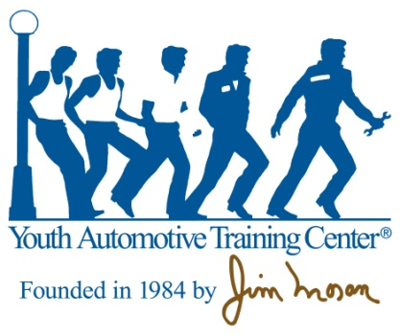

**www.yatc.org**

All raffle proceeds benefit the Youth Automotive Training Center,

a program for at-risk youth founded by Jim Moran.

® 1987, 2021 Youth Automotive Training Center of Broward County, Inc. All rights reserved.